URPERCENTILE
Visit : http://www.urpercentile.com/
Preparing for entrance exam for top Management Institute ?
Join Us.

HURDLE 46 :
Q1 To Q6 is based on the graph below which shows the exchange rate of Q$,Y$ and P$ compared to INR during 12 months of a year.

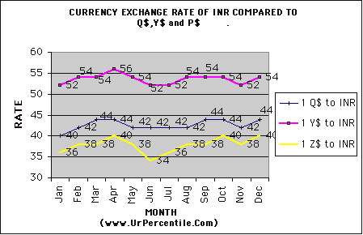

Q1. A Man has INR 50,000. He buys Q$ in Jan and sell the same in Oct to get INR and buys Z$ out of the proceeds. How many Z$ does he get ? a) 1375 b) 1475 c) 1575 d) 1325

Q2. Which currency when compared to INR showed the maximum increase from start of the year till the end of year, in terms of percentage?

Q3. A man has INR 500,000. What was the best he could have earned if he had option to convert it to other currency and back only once during the year?
- Convert to Z$ at 34 and convert back to INR at 40.
- Convert to Y$ at 40 and convert back to INR at 44.
- Convert to Q$ at 52 and convert back to INR at 54.
- Convert to Z$ at 40 and convert back to INR at 34.

Q4. Exchange rate of Q$ to Y$ is given by the formula (1 Q$ to INR/ 1Y$ to INR). If a person exchanges Q$ 100,000 to Y$ in May, how many Y$ will he get? A) 77,777. 77 B) 66,666.66 C) 77,700 D) None

Q5. Which currency compared to INR remained stable for longest duration and when?

Q6. What is the average exchange rate of Y$ to INR for the year ?
a) 53 b) 53.5 c) 54 d) 53.8
http://www.urpercentile.com/

Q7 to Q12 are based on the following chart which represents the amount of water filled or drained by three Pipes in corresponding time. As you can make out Pipe 1 and Pipe 2 are inlet pipe and Pipe 3 is a drain pipe.
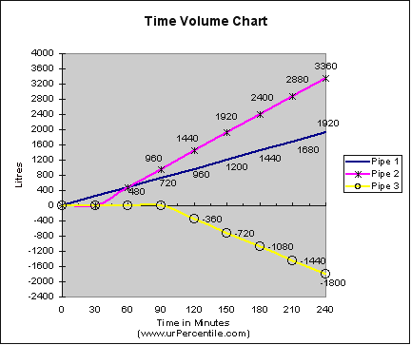

Q7. If all the 3 pipes are working , as represented in the graph, after how many minutes a tank of 2,400 liters will start overflowing ?
a) 150 mins b) 120 mins c) 160 mins d) 175 mins

Q8. If only Pipe 1 and Pipe 2 are working as per the graph timing and Pipe 3 is not activated how long will it take to fill a 2400 Liter tank ? a) 150 mins b) 120 mins c) 160 mins d) 175 mins

Q9. After how many minutes of the start of Pipe 2 did pipe 3 start functioning? A) 45 mins B) 60 mins C) 75 mins D ) 50 mins

Q10. If a tank of Capacity 4,800 liters is full and Pipe 3 starts its action, how long will it take to drain the tank out?
A) 300 min B) 400 mins C) 420 mins D) 450 mins

Q11. If all the three pipes start working at the same time how long will they take to fill a tank of 1,200 Liters ?
- 120 mins b) 100 mins c) 90 mins d ) 135 mins

Q12. If only Pipe 2 and Pipe 3 are working on a 100 Liters tank, how long will they take to fill it ?
a) 25 mins b) 30 mins c) 20 mins d) None

http://www.urpercentile.com/

Q13 to Q 18 are based on the graph below which represent the location of 4 cars at different times. Two of the Cars are traveling from Delhi, while two cars are traveling towards Delhi .

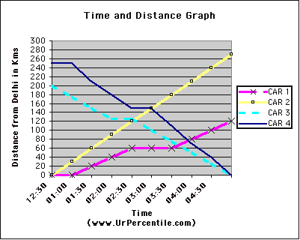

Q13. What is the distance between the two cities from where Car 3 and Car 4 start their journey towards Delhi?
a) 50 Km b ) 45 Km c ) 90 Km d) Cannot be determined

Q14. Which Car took no halt in between and which car took the halt for maximum duration ?

Q15. Which car had the maximum average speed?

Q16. How many hours did Car 4 took to reach Delhi after starting its journey? ( urpercentile. Com) a) 3.5 Hours b) 7 hours c) 4 hours d) 2 hours

Q17. How many Cars of Car 1, Car 3 and Car 4 did Car 2 meet during the journey?

Q18. Car 2 has to reach a destination 360 Kms from Delhi. At what time will it reach its destination if it continues to travel at the speed it traveled first 100 Km ?
http://www.urpercentile.com/

MATCH THE WORDS IN SET A WITH THEIR MEANINGS IN SET B

SET A Q19. Propinquity, Q20. Serried, Q21. Astigmatism , Q22. Iniquity, Q23. Chicanery, Q24. Toilsome.

SET B
A. Requiring hard work.
B. Exceptionally brave.
C. Crowded.
D. Deception especially by manipulation of language.
E. A visual defect which prevents proper focus.
F. Eat or drink too much.
G. Sabotage.
H. To get nervous due to lack of experience.
I. To steal somebody's property.
J. Perceptible by touch.
K. A gross immoral act or injustice.
L. Nearness in space time or relationship.

http://www.urpercentile.com/
PS QUESTIONS :

Q25 to Q 28 are based on the graph below which represent the salary and savings of 4 brothers.

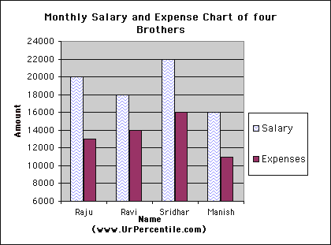

Q25. If the salary as well as expenses of all the four brothers increase by 10 % , what will be the total annual savings of the four? A) 24200 B) 290400 C) 264000 D) 22000

Q26. Who saves minimum percentage of his salary ?

Q27. If all the four brother decide to save Rs 8000 per month , who will have to reduce his monthly expenses the maximum among the four?

http://www.urpercentile.com/

Q28. In which country is the Guantanamo Bay located?
(1) Cuba (2) USA (3) Iraq (4) Mexico

Q29 . Which of the following countries is not a member of ASEAN?
1) Laos 2) Cambodia 3) Brunei 4) China

